Meal logging instructions for participants (FoodView App)

- Take photos of any foods/caloric beverages consumed (i.e. breakfast, lunch, dinner, snacks, caffeine). Ensure that the whole meal is shown clearly in the photo.

- Photos should be taken just before eating. Photo timestamps will be used to determine meal start and end times.

- For main meals (e.g. breakfast, lunch, dinner): take a “Before” photo showing whole meal just before you begin eating, and an “After” photo at the time you finish eating, showing any food left unfinished.

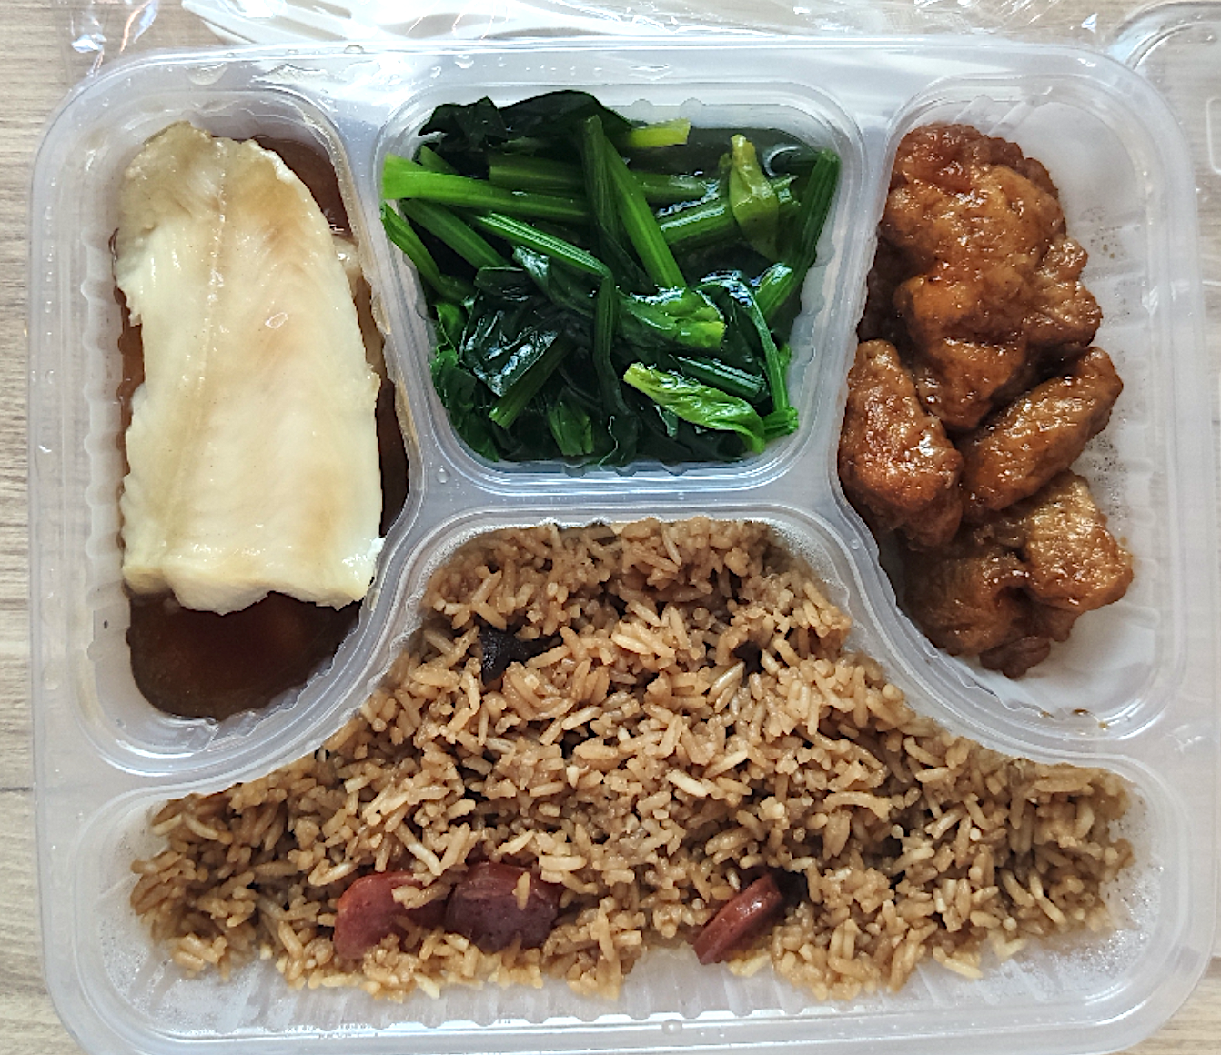
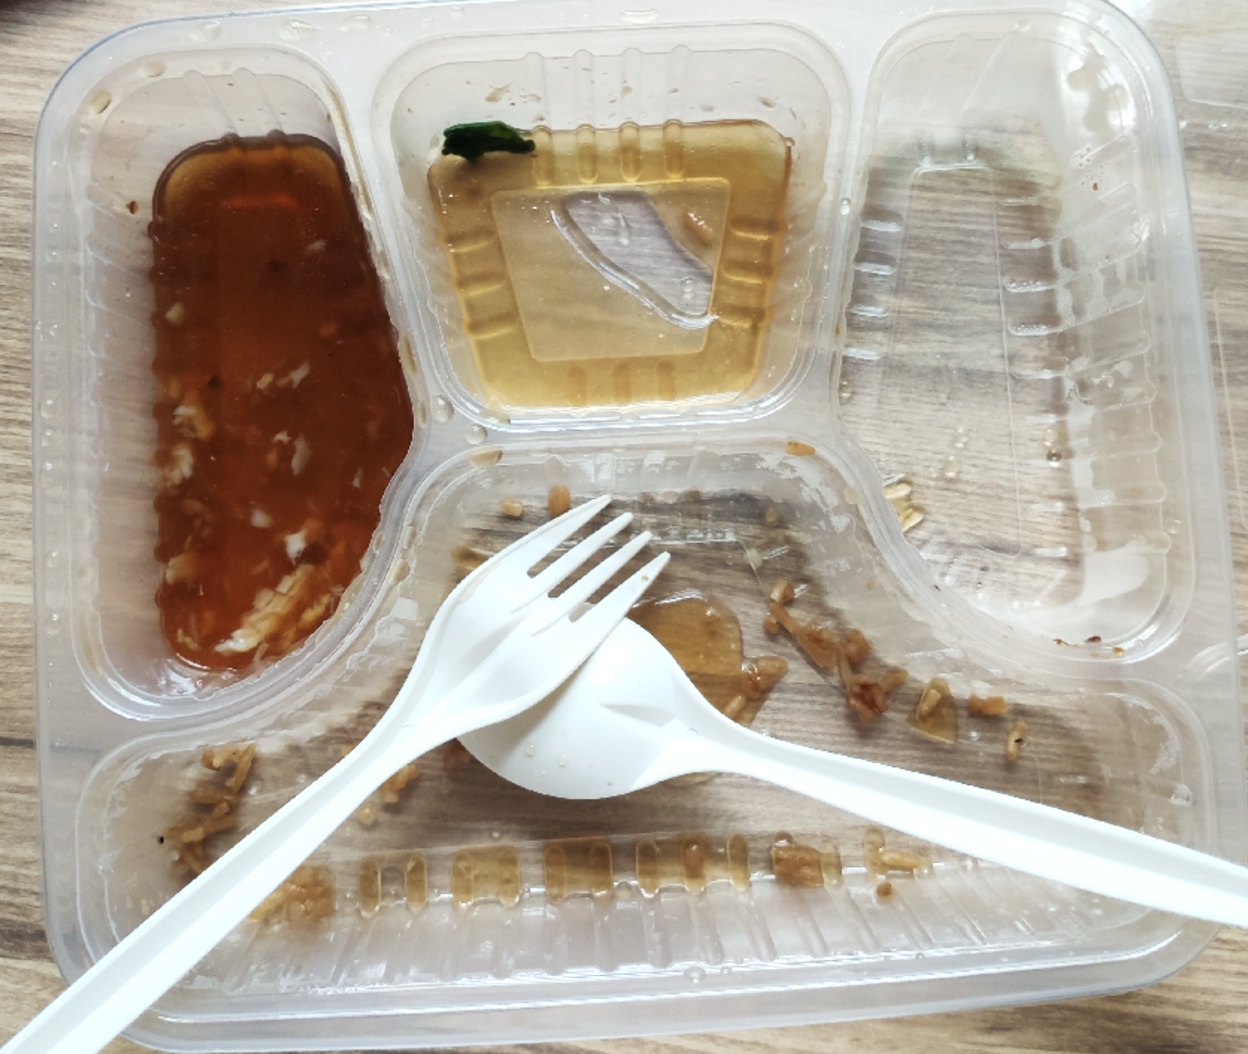
Before meal

After meal

- For foods where contents are not clearly shown/ambiguous (e.g home-cooked food, biscuits or drinks without packaging), please use the notes function to describe the contents.

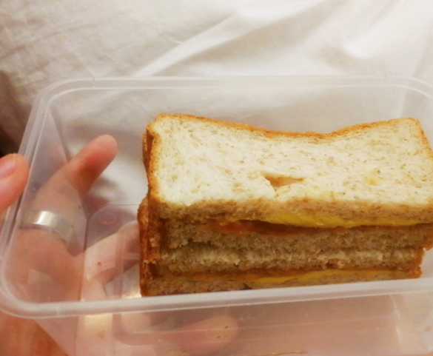
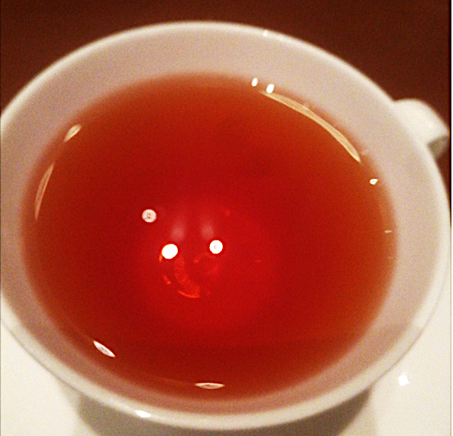
E.g. “Sandwich with wholegrain bread, lettuce, tomato and cheese”
E.g. “1 cup of black tea”

- If you missed taking a photo of any meal, please take a photo of a blank surface and record the missed meal using the notes function with the following information: start time, end time, food eaten, quantity (E.g. “1:05 PM – 1:20 PM, 2 bananas + 1 cup of milk”)

- For meals that include shared dishes, you can take a photo of the different dishes and use the notes function to estimate the portion you ate. E.g. 2 slices of pork, 1 portion of vegetables etc …

- Our staff will review your photos and may contact you should any clarifications be needed.

